Symantec
Quinn Banet

University of Louisville || College of Business

Quinn Banet
Dr. Barker
CIS 410-01
February 15, 2017

Case Write-up: Symantec

Overview
Symantec provided a diverse line of software to help businesses with their information management, software development, and productivity needs. They were a rapidly growing business that owed their success to the speedy acquisition of a couple key companies that boosted their product line.
Their core competency is their complete software solution they offered. They offered everything from application software, to systems software, and even utilities like their antivirus. They acted as a one-stop shop for business software needs. Symantec acquired a few key companies that lets them have the best and most diverse product line.
Symantec’s primary market is B2B transactions. This is businesses looking for software solutions. Any business, even in the ‘80s, needed some sort of application software or information management solution. This puts Symantec in very high demand and puts them in a good position, something that is reflected by their rapid growth from takeoff.
Their generic strategy is differentiation. Rather than being the cheapest product or focusing on a niche market, Symantec simply has the best line of products to offer their customers that is available on the market. Customers had alternative software solutions but the others were either not the quality and functionality that Symantec had to offer, or they did not offer the diversity in product line that Symantec had. Symantec specialized in it all when it comes to software solutions.

Mission Statement
Symantec offers a complete line of software solutions for business customers, differentiating their services from their competitors.

Company Strategy
Symantec’s strategy is built around their generic strategy of differentiation. As a company they seek to have both the best products for their customers as well as become a one stop shop for all their software needs. They have done this by starting off with a few key products and acquiring other business that also make superior products. The CEO has been very expressive that in order to keep this spirit of being the best and most creative in the industry, he would change as little as he could, operationally, to the companies Symantec would acquire. His purpose for this was to keep their creativity and engineering of new products and features at the highest level possible. This further drove Symantec’s strategy of differentiation: to be the best in the business to the point that being the “cheapest” in the business hurt more than it helped.

Organizational Strategy
As an organization, Symantec started off very unstructured. They had a CEO and a hierarchy, in terms of command, but as they acquired more and more business and divided into product teams and other groups they grew into a network structure. Whether they meant to or not this is the strategy they took on. Looking at Cash’s concepts they checked off all the boxes. The division of labor, coordination mechanisms, decision rights, boundaries, informal structure, politics, and authority all line up identically with a network structure (Cash 41). The CEO even came outright and dictated their strategy whether he meant to or not: “Once you obtain the products, you must keep building and maintaining them. You can’t lose the spirit…” In other words he was saying, you must maintain their innovation. This is the strategy of what a network structure is best suited for: innovation. If he truly wanted to have a strategy of differentiation, he should have structured the company to suit them best for diversification.

Porter’s Five Forces || ICA
When we consider Michael Porter’s Five Forces it helps to understand the company and their mission: what they do, and who/how they do it. These five key factors help evaluate potential opportunities and risks the company might face. The five forces cover: bargaining power of customers, bargaining power of suppliers, competitive rivalry, threat of new entrants, and threat of substitutes.
- Bargaining Power of Customers
Customer’s bargaining power was low, as Symantec had such a diverse line of products they had quite a number of customers. Anytime there are many customers they usually have little bargaining power. There also weren’t many other competitors for the customers to switch to, further decreasing their say to bargain with their supplier.
- Bargaining Power of Suppliers
Bargaining power here is slim-to-none. Symantec essentially did everything in-house. Being a software company they developed their products and don’t need any raw goods or anything to turn them to finished goods. This leaves their only supplier to be either office supplies or PCs to do their work on.
- Competitive Rivalry
There were a few big players in the game, so rivalry would be moderately high. Although both Symantec and a majority of customers would agree that Symantec’s products were superior, some could still go for the competitor. This uncertainty in the consumer is what makes the threat moderate and not extreme.
- Threat of New Entrants
Threat of new entrants is extremely high. It takes virtually no resources or large amount of capital to develop software. Symantec does have the fact that they have a complete product line of software going for them, but nothing is to stop a new entrant from developing a better product and seriously affecting one or multiple product lines.
- Threat of Substitutes
Just like entrants, substitutes are also extremely high. How many of the exact same sort of application do we see in any App Store? Any software can be closely copied or even reproduced into a better version that the original. It takes no capital or resources to duplicate Symantec’s products so their threat of substitutes is extremely high.

Problem Statement
Symantec had an unstructured organization from the get-go. This continued to get much worse as they acquired new businesses. They kept the newly acquired business’ way of doing things and only migrated the essentials to corporate, things like finance and human resources. For the most part, everything else about the newly acquired company remained the same. This did allow the company to retain its level of innovation and creativity that attracted Symantec to acquire them in the first place. However, this did not mean any sort of organization or structure. “An effective organization depends on developing a cohesive set of relations between structural design; the age, size, and technology of the firm… (Morgan 50).” Morgan is saying the company needs a proper balance of all its components to be effective. The company did not have a proper balance and was instead so disorganized and it started to show when attempted to communicate between departments or between product groups. Their “networks” all branched from the center like a web but could not communicate with each other very well.
It is true that Symantec’s main issue is in their communication issues. However, when we evaluate why that may be, it points further up the line. “…visions, values, and other dimensions of culture must create space in which productive innovation can occur (Morgan 100).” If their organization is structured in such a way that encourages communication and innovation rather than cuts in off at the product or divisional team, then they run into all the issues the case points to. The company tried to combat this with regularly scheduled meetings from divisions all the way up to the top. While this was successful there still was not much horizontal communication between the divisions or networks. “Certain groups did not communicate with each other…The product groups were not used to sharing information or being accountable to a parent organization.” They would try to fix this with meetings passing info from bottom to top but as you can see, they still experienced lack of horizontal communication. This had sales teams not communicating customer feedback back to the development teams, as well as marketing and engineering departments not hearing or sharing the info they possessed back down to the product groups or even across the groups. The CEO blew this off as “each [product team] knew the best way to do something and did not need to solicit information from others.” As much as the company tried to hold meetings or try to fix the communication issue, there is only so much to do if you do not attack the root cause: the organizational structure.

Stakeholders

Employees
The employees of Symantec hold a large stake in the success of the business. Their jobs literally depend on how well Symantec does, so as a result it can be assumed that they are invested in seeing the success of the company.

Shareholders
Investors obviously hold a very high stake in Symantec with trusting their finances in Symantec’s hands. They want the company to do well more so for their own personal and financial gain rather than just for the success of the company.

Customers
Symantec’s customers do not have that much invested in Symantec in terms of caring for their success. They really are only concerned that Symantec can stay afloat and continue to offer the products and services that they do.

Solutions || Alternatives

Do Nothing
Symantec can continue with the path they’re on, trying minimal changes to “improve communication.” They will keep holding meetings and attempting to change communication channels. They can try to incorporate some sort of cross-product, horizontal communication channel, however it is against the nature of a matrix structure.

Upgrade / Fix Current Systems
Symantec should fix their systems. They have constant issues with all of their main MIS systems including complete communication failure and network outages. Their current systems include The HP 935 system and their Network system, a Novell LAN connected their IBM PCs and clones. The HP system controlled their MIS functions and would constantly go down and could simply not handle the order volume that Symantec regularly pushed on its system. Order-entry employees would sometimes be sitting there for days at a time with no work to do, and then the system might crash when there finally are orders to process. Their network system primarily controlled their email and phone services. Their network system was one that handled 320 IBM PCs and PC clones. It housed their email and phones which are obviously heavily relied on for communication. This was also a system that could not contain its volume of usage and would constantly be down, affecting just about the entire organization.
If they upgraded their system to something that could handle the type of volume that they constantly experience, then they would be able to communicate without interruption. They would also likely have an improved system to balance work so there is no one sitting there waiting on work. The company would not be held at a standstill waiting for the system and could have peace of mind that it would not regularly crash.

Change the Organizational Stucture
The company can attack the root issue that is causing all of their communication problems. They need to change their structure from matrix to divisional. This will allow the company by nature to communicate across the divisions which is where all of their lack of communication stems from. This would allow each department or product team to be kept up to date with what is going on, and from there they can go up the line to upper management and executives like they already have no problem doing.
The CEO said that what he wants to do with the company, his strategy for acquired businesses is ultimately to keep productivity, creativity, and innovation at the same level that made Symantec want to acquire them in the first place. What the CEO really meant by wanting to keep up all their innovation was that he wanted the product to be the best it could be and to keep it that way. He wanted to keep the company strategy one of differentiation and keep his product line a diverse one. “The divisional structure works well when coordinated action is required to develop innovative products…It is most often seen in organizations that have adopted a diversified strategy of producing multiple products… (Cash 36).”
To do so he would need to change their matrix structure to a divisional structure that focuses on diversification which is exactly their goal in a differentiation strategy.

Stakeholder Impact

DO Nothing
Employees
If nothing changes structurally and no upgrades are made, the company will continue to make minor communication changes. Employees will likely become very frustrated. The case already talks of how employees are frustrated with the way things are and you can only imagine how much more frustrated they would continue to get if nothing changes.
Shareholders
Shareholders would not be phased. They would not usually know the ins and outs of the business they are investing in and likely wouldn’t even know of the communication issues in the first place. As long as the company continues to grow and report positive news to their investors, they couldn’t care less and would be happy.
Customers
Customers would also be happy. They would not know that Symantec is having communication issues unless it gets to the point that it affects product development, in which case customers would be upset and switch to competitors. However, the case never talks of the communication getting so bad that it affects their products, so customers would likely be happy or not phased with the “do-nothing” approach.

Upgrade / Fix Current System
Employees
Symantec’s employees would be thrilled. They have complained extensively about how poorly and job-affecting the current systems are. The employees would be happy to see systems that are the result of their feedback and that no longer crash regularly.
Shareholders
Shareholders again would not be involved in this level of detail. Just like the do nothing approach, all they care about is positive numbers and increases shares. As long as that is the result, they are happy.
Customers
Customers would not see these changes but could potentially be impacted if before the new system, communication was affected to the point that it affects Symantec’s products. In this case, customers would be happy.

Change the Organizational Structure
Employees
Symantec’s employees would probably be split, half would hate the change and half might see what good it could bring. In general, no one likes change, so it could be assumed that the employees would not be happy at first. Once they start to see the advantages in communication they would see that the change was beneficial.
Shareholders
Shareholders again would not be involved in this level of detail. As long as that is the result, they are happy.
Customers
Customers would not see these changes but could potentially be impacted if before the new system, communication was affected to the point that it affects Symantec’s products. In this case, customers would be happy.

CONCLUSION
Selected Option – Change the Organizational Structure
Symantec has tried extensively to make their current structure work and it just does not. They have tried scheduled meetings, directed publications and internal reports, staff meetings, weekly executive meetings, and so many more. They try to force communicate at every chance but there is only so much you can force an organization to do if they’re just not set up that way. It should not take forcing but should instead be natural.
A divisional structure is perfect for Symantec. Not only would it allow them to communicate across product groups and be able to finally have horizontal communication, but it would also allow them to be better organized as a business, and see other structural improvements. Divisional structure is one that is organized around output: in this case, Symantec’s line software solutions that they offer. The CEO said it best when he said “You can’t lose the spirit and the people behind a product” What he really wanted here was to keep the original ingenuity and innovation. This is a perfect fit because a “divisional structure works well when coordinated action is required to develop innovative products (Cash 36).”
If you look at the strategy effectiveness chart below (Cash 41) you can clearly see that a divisional structure would suit Symantec best. Going down the chart Symantec should change to a divisional structure because they really don’t have many resources as they are a software company so resource efficiency is not something that is important. Time efficiency is something that may slightly decrease when switching from network to divisional but again, time efficiency is not something that is all that important in a software company. Their products already work and updates can come in their own time. Responsiveness is very similar to time in this case, something that will slightly decrease but not a vital portion of the company. They need to adapt only when they take in new businesses, so again, not a huge issue. Now for the advantages: Symantec can have much greater accountability for anything and everything in their organization. In the past sales teams may not know where to send customer feedback or may just not even communicate that. Things like this could be accounted for. Symantec is a heterogeneous environment being forced into a volatile environment and making this switch could be largely advantageous. Perhaps the largest advantage they will gain and one that aligns with their company strategy of differentiation is to diversify their product line.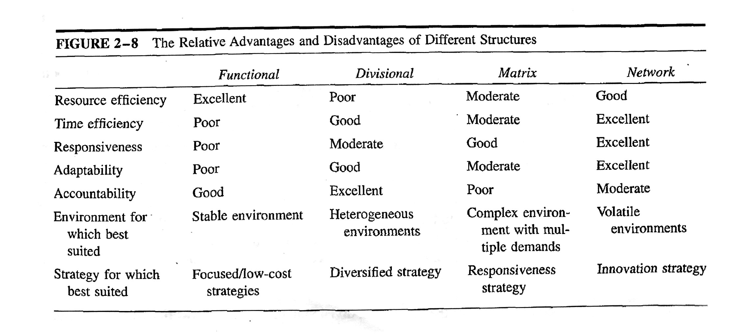
In order to have a strategy of differentiation you product line has to be both the deepest and the widest, or the best and largest, which is something Symantec has but is not structurally setup to support. Making this change would be enormously advantageous to Symantec and would see all their stakeholders happy. Employees would, after time, love the change, shareholders would see larger ROIs, and customers would see better products as a result.
Neglected Option – Upgrade / Fix Current System
Symantec should chose to do something, but upgrading the system or fixing their current kinks is just postponing the inevitable. They will continue to grow whether their system can handle it or not, they have superior products to everyone on the market and their customers know it. However if they chose to just upgrade their systems they are essentially postposing the results of the do nothing outcome. They will grow, but do they want that rate of growth to also continue or would they like their rate of growth to drop? It most certainly will not continue at the rate that it is if they do not make a major change, not just doing nothing, and not just prolonging their communication issues from catching up with them.
Neglected Option –Do Nothing
If Symantec truly is to do nothing we could assume that communication would eventually reach a point that it becomes affecting. Hurting their product development and innovation which could in turn affect numbers: something the investors see and obviously care about. This is easily the worst option for Symantec to choose. If communication reaches business impacting levels, something that is inevitable with their current systems and rate of growth, then it leaves every stakeholder furious with Symantec. This is a very real issue and one that Symantec cannot afford to not take seriously. They must choose at the very, to do something. Their business depends on it as do their shareholders.

